
Government of Antigua and Barbuda

The Transfer of Jolly Beach to Social Security
A Strategic Imperative
By
Prime Minister Hon. Gaston Browne

Government of Antigua and Barbuda
August 2025

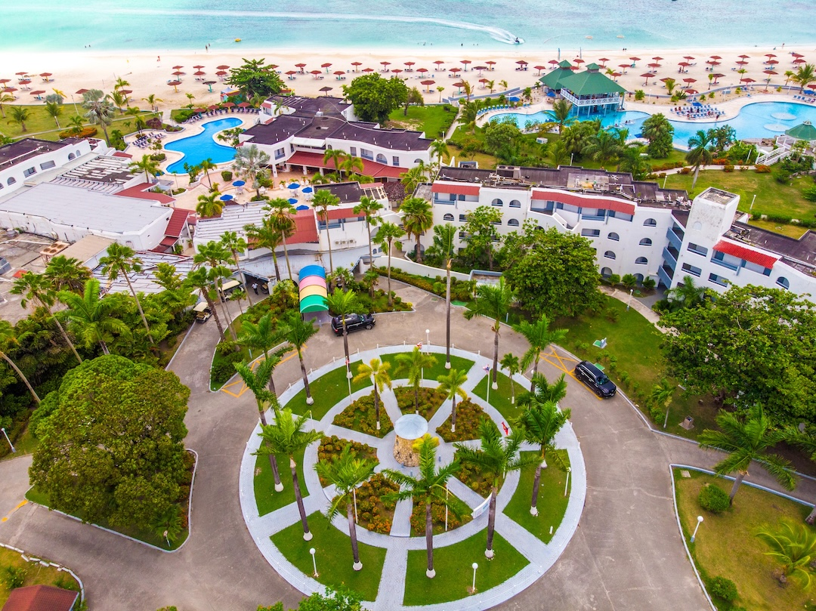

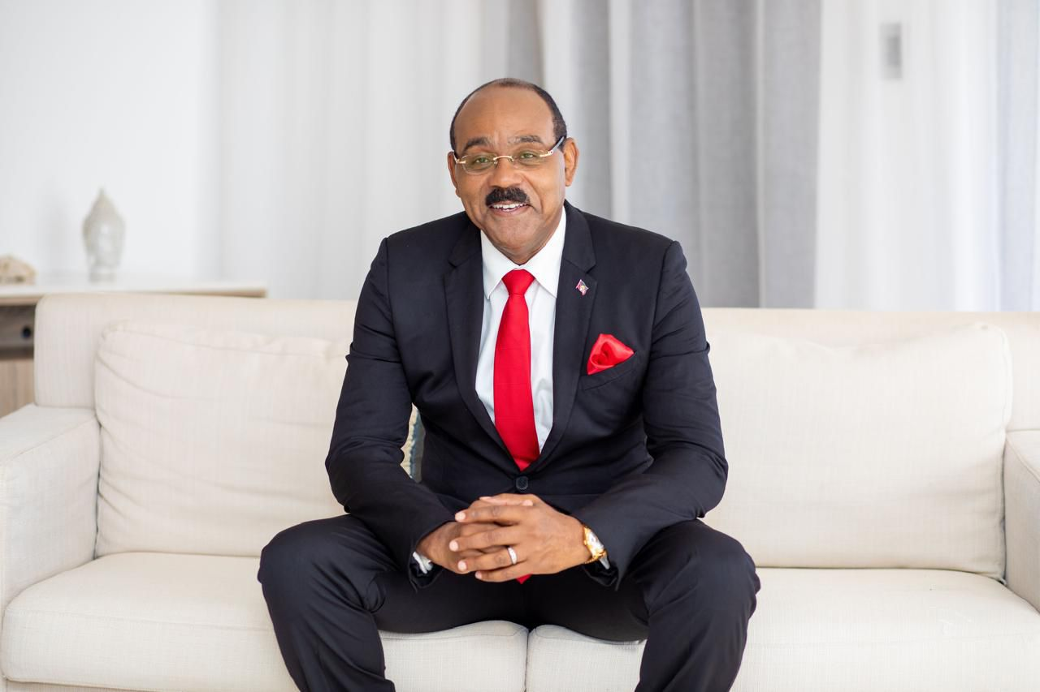

Foreword
In 2014, our Administration embarked on a bold journey: to rebuild Antigua and Barbuda by harnessing our people's talents, skills, and goodwill. We envisioned not mere recovery but transformation, turning our unitary state into a Caribbean economic powerhouse. From day one, we knew transformation wasn’t instant or inherited. It would demand our generation's sweat, intellect, perseverance, and a dramatic break with the old colonial extractive model.
We coined a new paradigm— “Entrepreneurial Socialism” or “Empowerment Capitalism—a system under which the State partners with the private sector to generate profits that are then socialized through taxes and dividends, fueling social and economic development. In this model, the government must be entrepreneurial: seeking strategic investments, aligning public and private incentives, and ensuring that every dollar of profit enriches our people rather than departing abroad.
Architecting our development means crafting a destiny of creativity, ownership, and self-reliance. It demands that each citizen embrace hard work, strategic thinking, and an entrepreneurial spirit—whether at the micro level of individual enterprise or the macro scale of national infrastructure. Accordingly, we have invested heavily in education and skills training so that all Antiguans and Barbudans can be qualified to participate at the highest levels of our nation's advancement.
We have already demonstrated the power of this approach. Where once significant assets belonged to foreign owners, they now belong to our people. For instance, WIOC, formerly foreign-controlled, is now majority-owned by the government and people of Antigua and Barbuda. Its retained profits and dividend payments—over EC$160 million in the past decade—have been invested to drive further growth. Another example is that, benefiting from the Government's policies to ensure Canadian bank branches could only be sold to domestic banks, our domestic banks posted combined profits of EC$110 million last year. These profits remain in our economy rather than being repatriated abroad.
The next logical step in our national blueprint is focused on the Jolly Beach Hotel and how it can be utilized to maximize the returns on investment through our Social Security Scheme. By transferring ownership of this tourism resort to the Social Security Scheme, renovating and expanding it under Empowerment Capitalism, we will generate sustainable profits for our people and fortify the pension scheme that safeguards their livelihoods in retirement.
When some in the Opposition insisted on selling to foreign interests, I was flabbergasted. Such an action would not only fail to “emancipate ourselves from mental slavery,” but it would also send the profits from our people’s investment abroad. This is why we opted to exchange this irreplaceable real-estate asset for a portion of our delinquent bond, thus reducing our debt while earning a higher yield from the investment in the Social Security Scheme’s investment assets—a clear win for Antigua and Barbuda.
To suggest that only a foreign godfather could make Jolly Beach succeed is to cling to the dependency and risk-aversion syndrome we have spent a decade overturning. We have invested hundreds of millions of dollars in educating thousands of our citizens. We possess the intellectual capital, creativity, and resilience to make the Jolly Beach Hotel and every other project a triumphant testament to our nation’s capacity and great potential.
No country advances by standing still or waiting for validation from abroad. We must be both the sponsors and the architects of our development. As your elected Prime Minister, I stand ready to build alongside you, leveraging our broad talents, indomitable spirit, and unified strength to realize our vision of a vibrant nation.
In the following pages, you will find the detailed plan for transferring the Jolly Beach Hotel to our Social Security Scheme. Under this plan, the Social Security Scheme converts a non-performing EC$330 million government bond into a performing asset transferred at a set-off value of EC$137.7 million (US$51.0 million). Based on the ten-year sales plan in this booklet, the project delivers net receipts of EC$392.75 million (US$145.46 million) into a dedicated, third-party escrow account over ten years. That is more than twice the EC$192.3 million residual on the original bond.

At the same time, the value of the asset will increase exponentially. This strategic initiative will:
- Strengthen the Social Security Scheme with a reliable, above-inflation revenue stream—transforming a dormant liability into an engine of prosperity for every pensioner;
- Expand national ownership of productive enterprises, ensuring that profits remain in Antigua and Barbuda to be reinvested in schools, hospitals, and infrastructure;
- Empower our homegrown managers, giving Antiguans and Barbudans trained in hotel and corporate management the opportunity to lead, innovate, and grow their careers and our economy.

-Pay off the residual amount of EC$192.3 million on the original bond of EC$330 million.
Together, we will secure tomorrow’s pension checks and forge a broader culture of ownership and professional excellence. Let us move forward confidently, knowing that by building the Jolly Beach Hotel into a world-class, citizen-owned enterprise – owned by the Social Security Scheme - we are advancing the interests of all Antiguans and Barbudans, and laying another firm cornerstone of our economic powerhouse.
Your faithful servant.
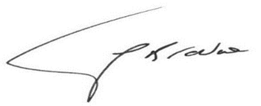
Gaston A. Browne MP
Prime Minister
and Minister of Finance and Empowerment

The Transfer of Jolly Beach to Social Security
A Strategic Imperative

Background
In partnership with our National Social Security Scheme, the Government of Antigua and Barbuda proposes a strategic investment in the Jolly Beach Hotel to boost Social Security revenues and ensure the long-term sustainability of the Scheme. The resort now comprises 318 rooms on 27 acres of pristine beachfront land, valued at EC$137.7 million. That valuation will be set off against outstanding interest and a partial principal reduction of an EC$330 million delinquent government bond issued in 2010, a bond that has never been serviced and today stands as a non-performing asset on Social Security’s books.
Another 32 rooms will be returned to service, allowing 350 rooms to be offered under the Citizenship by Investment Programme (CIP). All CIP owners will be permitted approximately two weeks’ private use per year of their units, which will otherwise remain in the rental pool in perpetuity.
Additionally, 200 more rooms will be constructed for CIP purchase and use as part of the hotel resort's room stock.
How the Social Security Scheme gets ownership of Jolly Beach Hotel
The Government will transfer legal ownership of Jolly Beach Resort to the National Social Security Scheme. The resort has been professionally valued at EC$137.7 million. That EC$137.7 million value will be set off against part of the Government obligation that Social Security currently holds — the EC$330 million instrument recorded in 2010. In short, Social Security exchanges a paper promise from the Government (the old IOU) for a real, marketable asset.
Note: The United Progressive Party (UPP) incurred this IOU to the Social Security Scheme, which was never honoured. The UPP ran up many unpaid debts, of which this was only one.
The Social Security Scheme receives cash in this new arrangement
The Social Security Scheme will garner money from the new arrangement because it will receive the proceeds of the sales of individual hotel rooms under the Citizenship-by-Investment (CIP) programme. CIP buyers purchase title to rooms but have strictly limited private use (approximately two weeks per year). Those rooms remain in the hotel’s managed rental pool for the remainder of the year (around fifty weeks), so the resort continues to generate operating revenue as part of the hotel business.

How CIP money will be handled
All gross CIP receipts are deposited into an independent escrow account (audited and managed by a neutral trustee), appointed by the Social Security Scheme and the Citizenship by Investment Unit, under Cabinet oversight.
Transaction closing costs, commissions, and applicable taxes are paid from the escrow account. The escrow then distributes the remaining net proceeds according to the published, legally binding payment priorities agreed in advance. Payment priorities may allocate funds to capex/expansion and surpluses to be invested in other investments.
Benefits to the Social Security Scheme
In addition to upfront CIP receipts, the Social Security Scheme will receive a continuing revenue stream from hotel operations (annual net profits) and homeowners’ fees. Together, these provide immediate cash and ongoing income to strengthen the Scheme.
Financial Investment Summary
CIP proceeds — Assumptions
Existing CIP units: 350 (operational + returned).
New expansion CIP units: 200.
Price per existing unit (gross): EC$900,000.
Price per expansion unit (gross): EC$1,300,000.
Development & SG&A cost per expansion unit: US$250,000.
CIP proceeds — existing units (350 @ EC$900,000 gross)
Gross: EC$315,000,000 (US$116,666,667)
SG&A & upgrade costs: EC$135,000 per unit × 350 = EC$47,250,000 (US$17,500,000)
Net proceeds: EC$267,750,000 (US$99,166,667)
CIP proceeds — expansion units (200 @ EC$1,300,000 gross)
Gross: EC$260,000,000 (US$96,296,296)
Development & SG&A costs: US$250,000 per unit × 200 = US$50,000,000 (EC$135,000,000)
Net proceeds: EC$125,000,000 (US$46,296,296)
Aggregate net receipts (both phases)
Total net: EC$392,750,000 (US$145,462,963)
Average annualized net yield (10 years): EC$39,275,000 per year (US$14,546,296 per year)

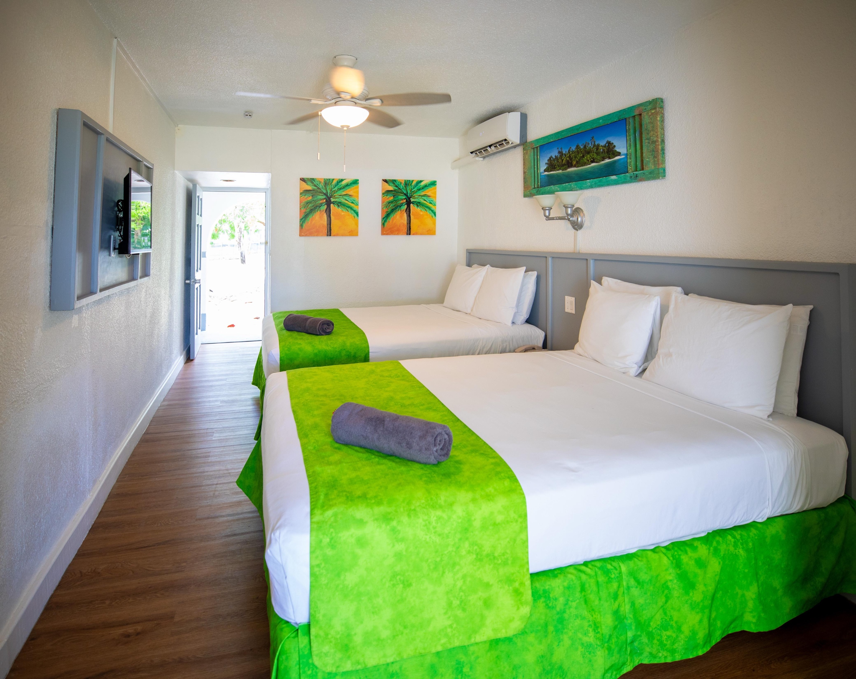

(Notes: US$ figures are simple conversions at EC$2.70 per US$1.00 and rounded to the nearest dollar. Development & SG&A for the expansion are treated as costs (not net), ensuring net proceeds = gross – costs.
SG&A stands for Selling, General, and Administrative expenses, which include ongoing overheads such as marketing, sales commissions, legal, audit, management, payroll, and office costs.)

Fixed-rate comparison:
- Investing EC$212,700,000 (EC$137.7 M + EC$75M) at 2% yields EC$4,254,000/year (US$1,575,556/year).
- Stress test: if CIP-driven net proceeds are halved for prudence, annualized receipts approximate EC$20,137,500 (US$7,458,333) per year — still EC$15,883,500 (US$5,882,778) per year greater than a 2% fixed alternative.

Beyond Debt Relief: Sustainable Operations
The Social Security Scheme can operate the Jolly Beach Hotel Resort directly or hold it under a professionally managed arrangement. Under disciplined professional management, targeted marketing, and operational efficiencies, the property’s net performance can significantly improve from current net results. The renovation and service upgrades in Appendix F will materially increase the resort’s competitiveness and pricing power. In addition to the income gains, there is also the potential for capital appreciation gains.
Homeowners’ operational fees (reconciled): All 350 CIP units paying EC$1,000/month each would generate EC$4,200,000/year (US$1,555,556/year) earmarked for routine maintenance and resort plant upkeep.
When the additional 200 rooms are built and sold; maintenance fee revenues will increase to EC$5, 500, 000, with the possibility of surplus to enhance profitability.
Pensions are protected; capital risk sits with unit owners
What carries the risk? Under the CIP model, individual rooms are sold to private buyers who assume the capital risk on their units. The Social Security Scheme receives cash at closing (through an independent escrow with published payment priorities). Owners’ private use is limited (about two weeks per year); for the other 50 weeks, the rooms stay in the hotel’s managed rental pool, generating operating revenue for the resort.
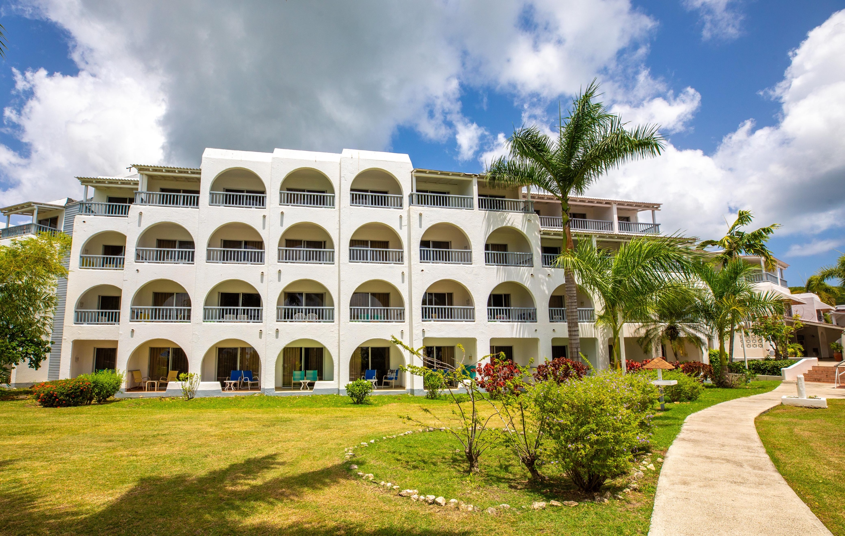

Two separate cash streams—both are additive to the Scheme.
- Net CIP proceeds averaging EC$40,275,000 per year over ten years (US$14,916,666/yr) are realised from unit sales.
- Ongoing operating income (room revenue, F&B, conference) plus homeowners’ fees strengthens the hotel P&L and the Scheme’s recurring cash flow. (These CIP proceeds are capital receipts; operating profits are measured separately—see the 2024 P&L Appendix.)
Safeguards:
- Insurance and SG&A: Insurance and other operating protections are already included in SG&A.
- Reserves & staging: Proceeds fund explicit reserves and staged refurbishment/expansion, so spending tracks real cash, not hopes.
- Escrow controls: An independent escrow releases funds only according to published, legally binding rules (covering costs, reserves, agreed capex.
- Transparency: Audited accounts and regular parliamentary reporting keep the process open.

Government backstop—targeted and capped
The Government will provide a defined, transparent guarantee to cover specified shortfalls or an orderly exit, if required. Terms (scope, caps, duration, triggers) will be published. This prudential last-resort measure preserves principal and confidence while the Scheme realises long-term value.
Bottom line
The Scheme swaps a non-performing IOU for a cash-generating national asset, without tapping pension contributions or exposing pensioners to owner-level capital risk. With escrow controls, reserves, insurance, transparency, and a narrowly tailored government backstop, the Scheme’s exposure is low and well-bounded while the upside—CIP proceeds plus improved hotel earnings—is material.
Operational performance: Hotel returned net profit of EC$3 million in 2024
The Jolly Beach Hotel recorded net profits of approximately EC$3.0 million (US$1.11 million) in 2024. With the planned refurbishment, the commissioning of the conference facility and related amenity upgrades, net profits are projected to rise to approximately EC$4.0 million (US$1.48 million) in 2025. These improvements will lift ADR, occupancy, and ancillary revenue and strengthen the resort’s operating margins.
For the primary evidence supporting current performance and the detailed line-by-line reconciliation, see Appendix G — Jolly Beach Hotel: Management Accounts to 31 December 2024 (P&L), One-page Annotated Summary, and the full P&L at Appendix G-2. (Exchange rate used for convenience: EC$2.70 = US$1.00.)

Pension-Fund Asset Classes
Pension schemes worldwide combine liquid and illiquid assets to meet short-, medium-, and long-term obligations. Short-term deposits (0–2% yields) preserve liquidity but commonly underperform inflation. Overdependence on such instruments erodes purchasing power and undermines long-term solvency—an outcome Antigua and Barbuda’s Social Security Scheme experienced by 2010. Carefully selected real estate, combined with responsible governance, performs as an inflation hedge and a durable revenue stream.

Incompetence and Failure
Historical inaction worsened the Scheme’s position. Prior leaders delayed critical measures rather than introducing parametric reforms, raising premiums, and adjusting retirement age to restore solvency. Pensioners suffered late payouts and indignities. Our Administration acted in 2016 to reverse that decline and now works to secure the Scheme for the future.

Parametric Changes
Our Administration took decisive action: EC$200 million was injected over ten years, and a negotiated EC$75 million bond payment to be made this year —EC$275 million in eleven years—restored solvency and put the Social Security Scheme back on a steady footing.

Rationale for Illiquid-Asset Investments
Well-governed portfolios commonly allocate a portion of assets to real estate to preserve purchasing power and generate above-inflation returns. The Jolly Beach Hotel is a tangible, revenue-generating asset with proven market interest via the CIP platform; converting a dormant EC$330 million bond into a productive asset is prudent and consistent with global pension fund practice.

Transparency & Accountability
To safeguard the Scheme and public trust, we will institute:
- Professional audits and semi-annual parliamentary reporting;
- A strengthened Investment Committee with independent experts;
- Cabinet and Ministry of Finance oversight;
- Rigorous due diligence, capped exposures, liquidity buffers, routine reviews, independent valuations, and stress testing.

Benefits
  - Economic Growth & Development: Increased tourism, foreign exchange earnings, and tax revenue.
  - Pension Sustainability: Above-inflation returns to underpin benefit payments.
  - Job Creation: Hundreds of construction and hospitality positions.
  - Entrepreneurial Spin-offs: New small-business opportunities around the resort.
  - National Pride: Domestic ownership of a revitalized landmark.
  - Enhanced Airlift: Greater connectivity to support visitor growth.

Response to Criticism by the Opposition
Since the government announced its plan to transfer the Jolly Beach Hotel to the Social Security Scheme, the opposition has dismissed the initiative as a risky, tourism-dependent real estate gamble, even accusing us of ‘playing Warri’ with the people’s money. This critique, however, fails on three counts:
- Mischaracterizing CIP: These are pre-funded, vetted investments—funds delivered to the Social Security Scheme upon closing—rather than leveraged borrowing. Immediate liquidity is central to the debt-reduction and capex plan.
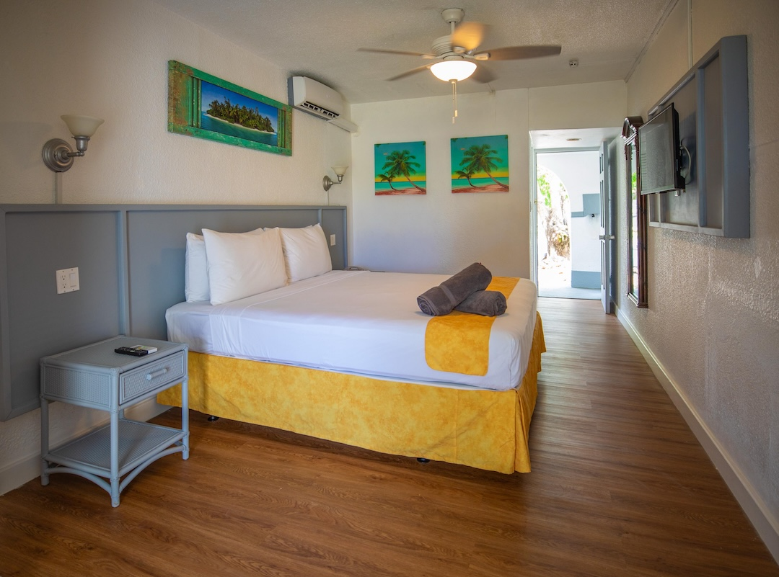

- Ignoring the Bond’s True Status: The EC$330 million instrument earns nothing today because of historic default. To keep an extinguished IOU on the books is to accept zero value; swapping it for a cash-generating asset is prudent stewardship.

- Overlooking Robust Safeguards: We will publish financial projections, audited hotel statements, and CIP-sale agreements; subject them to independent review; and report results to Parliament. This process will be fully transparent and auditable.
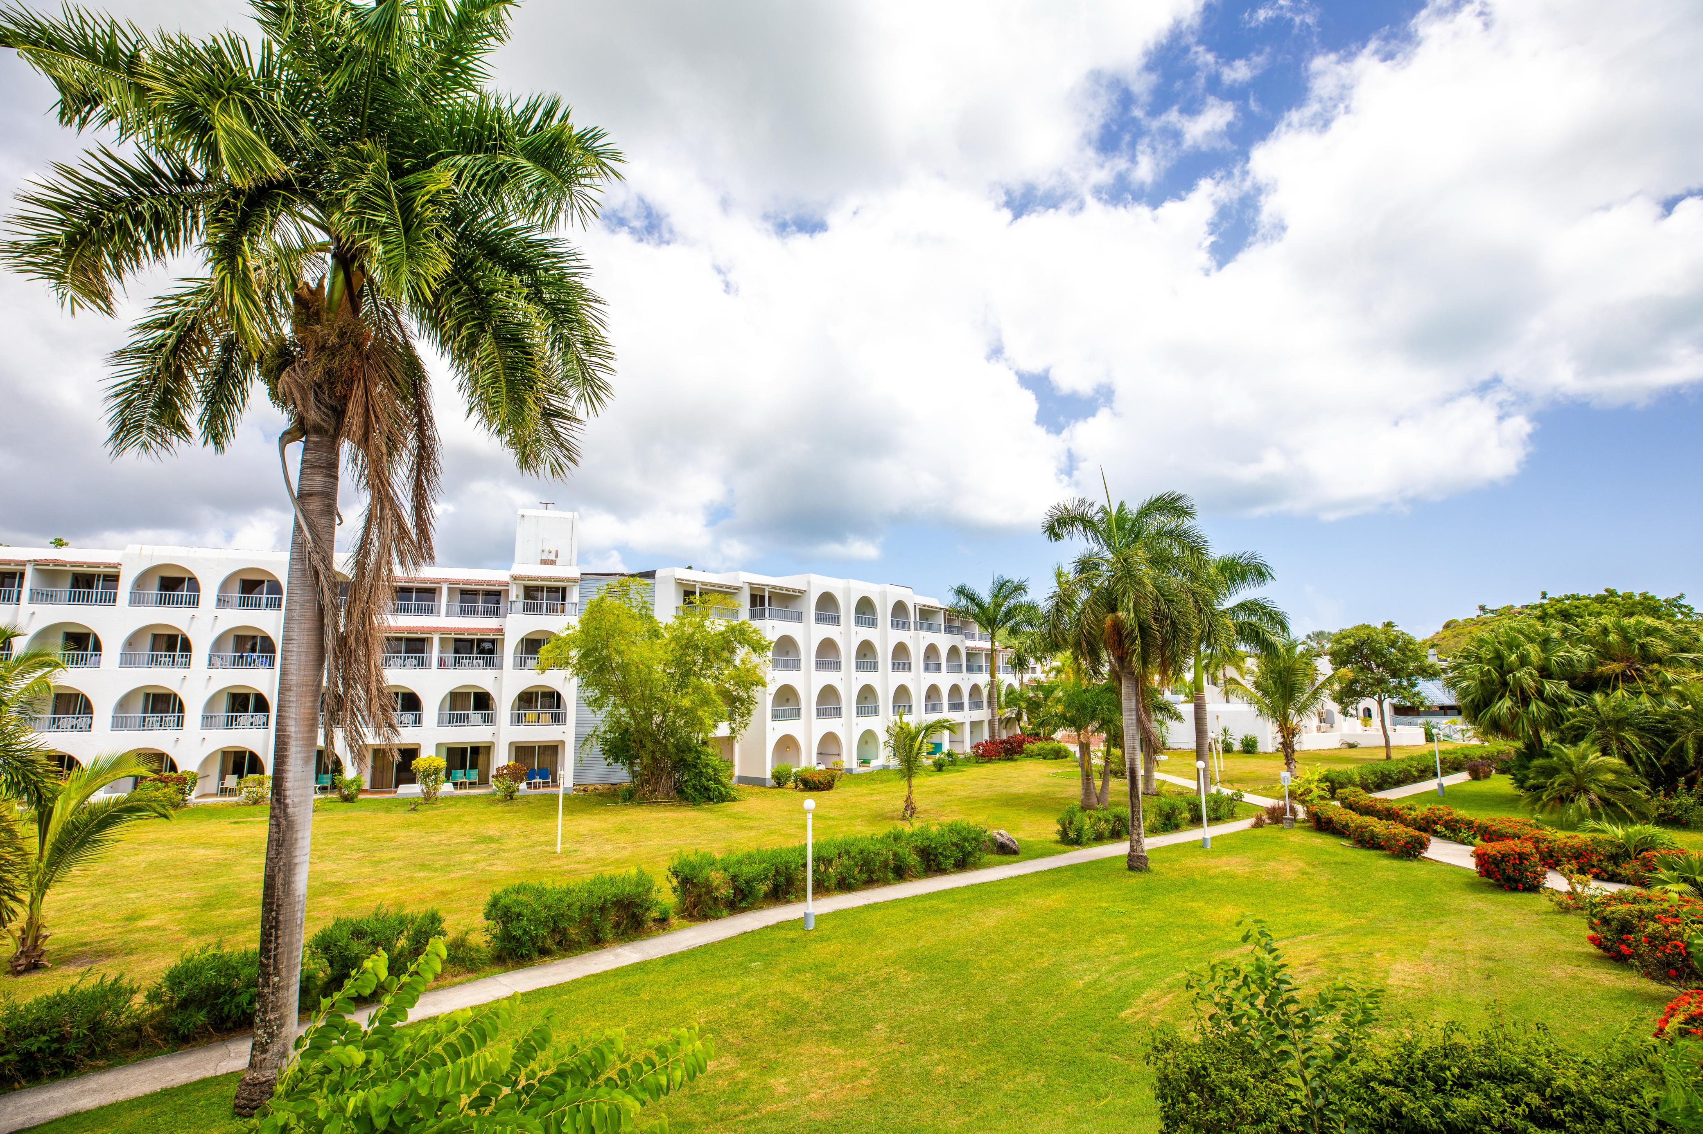

Validation of Strategic Soundness
Independent analyses show Antigua and Barbuda’s CIP Unit generated over US$60 million in real-estate sales last year—evidence of strong investment demand. Comparable Antigua resorts report 65–70% occupancy. Converting a zero-yield EC$330 million bond into EC$422,352,941 of net CIP proceeds and anticipated hotel profits aligns with global best practice—where pension funds typically allocate 10–20% to real estate for diversification and inflation hedging.

A Legacy of Prosperity and Pride
This arrangement is a covenant with every citizen and resident. From construction crews to hotel staff to entrepreneurs poised to launch new ventures, the Jolly Beach Hotel will become a symbol of shared success, diversifying our economy, deepening airlift, and generating foreign exchange. Above all, it will secure retirements for thousands of people and ensure that the Social Security Scheme remains a solid income guarantee for future generations.

Conclusion
By transferring the Jolly Beach Hotel to ownership by the Social Security Scheme and unlocking its potential with the CIP, we do more than regularize and reduce the liability; we ignite an anvil to forge sustainable growth. This strategic initiative blends prudence with boldness, guaranteeing tomorrow’s pension checks and harnessing our country’s natural assets for the benefit of our people. We also empower Social Security with superior returns to ensure its sustainability, thereby securing future pension payments.
The ABLP Administration commits to delivering this promise—turning white sands into golden returns for the nation’s shared future.
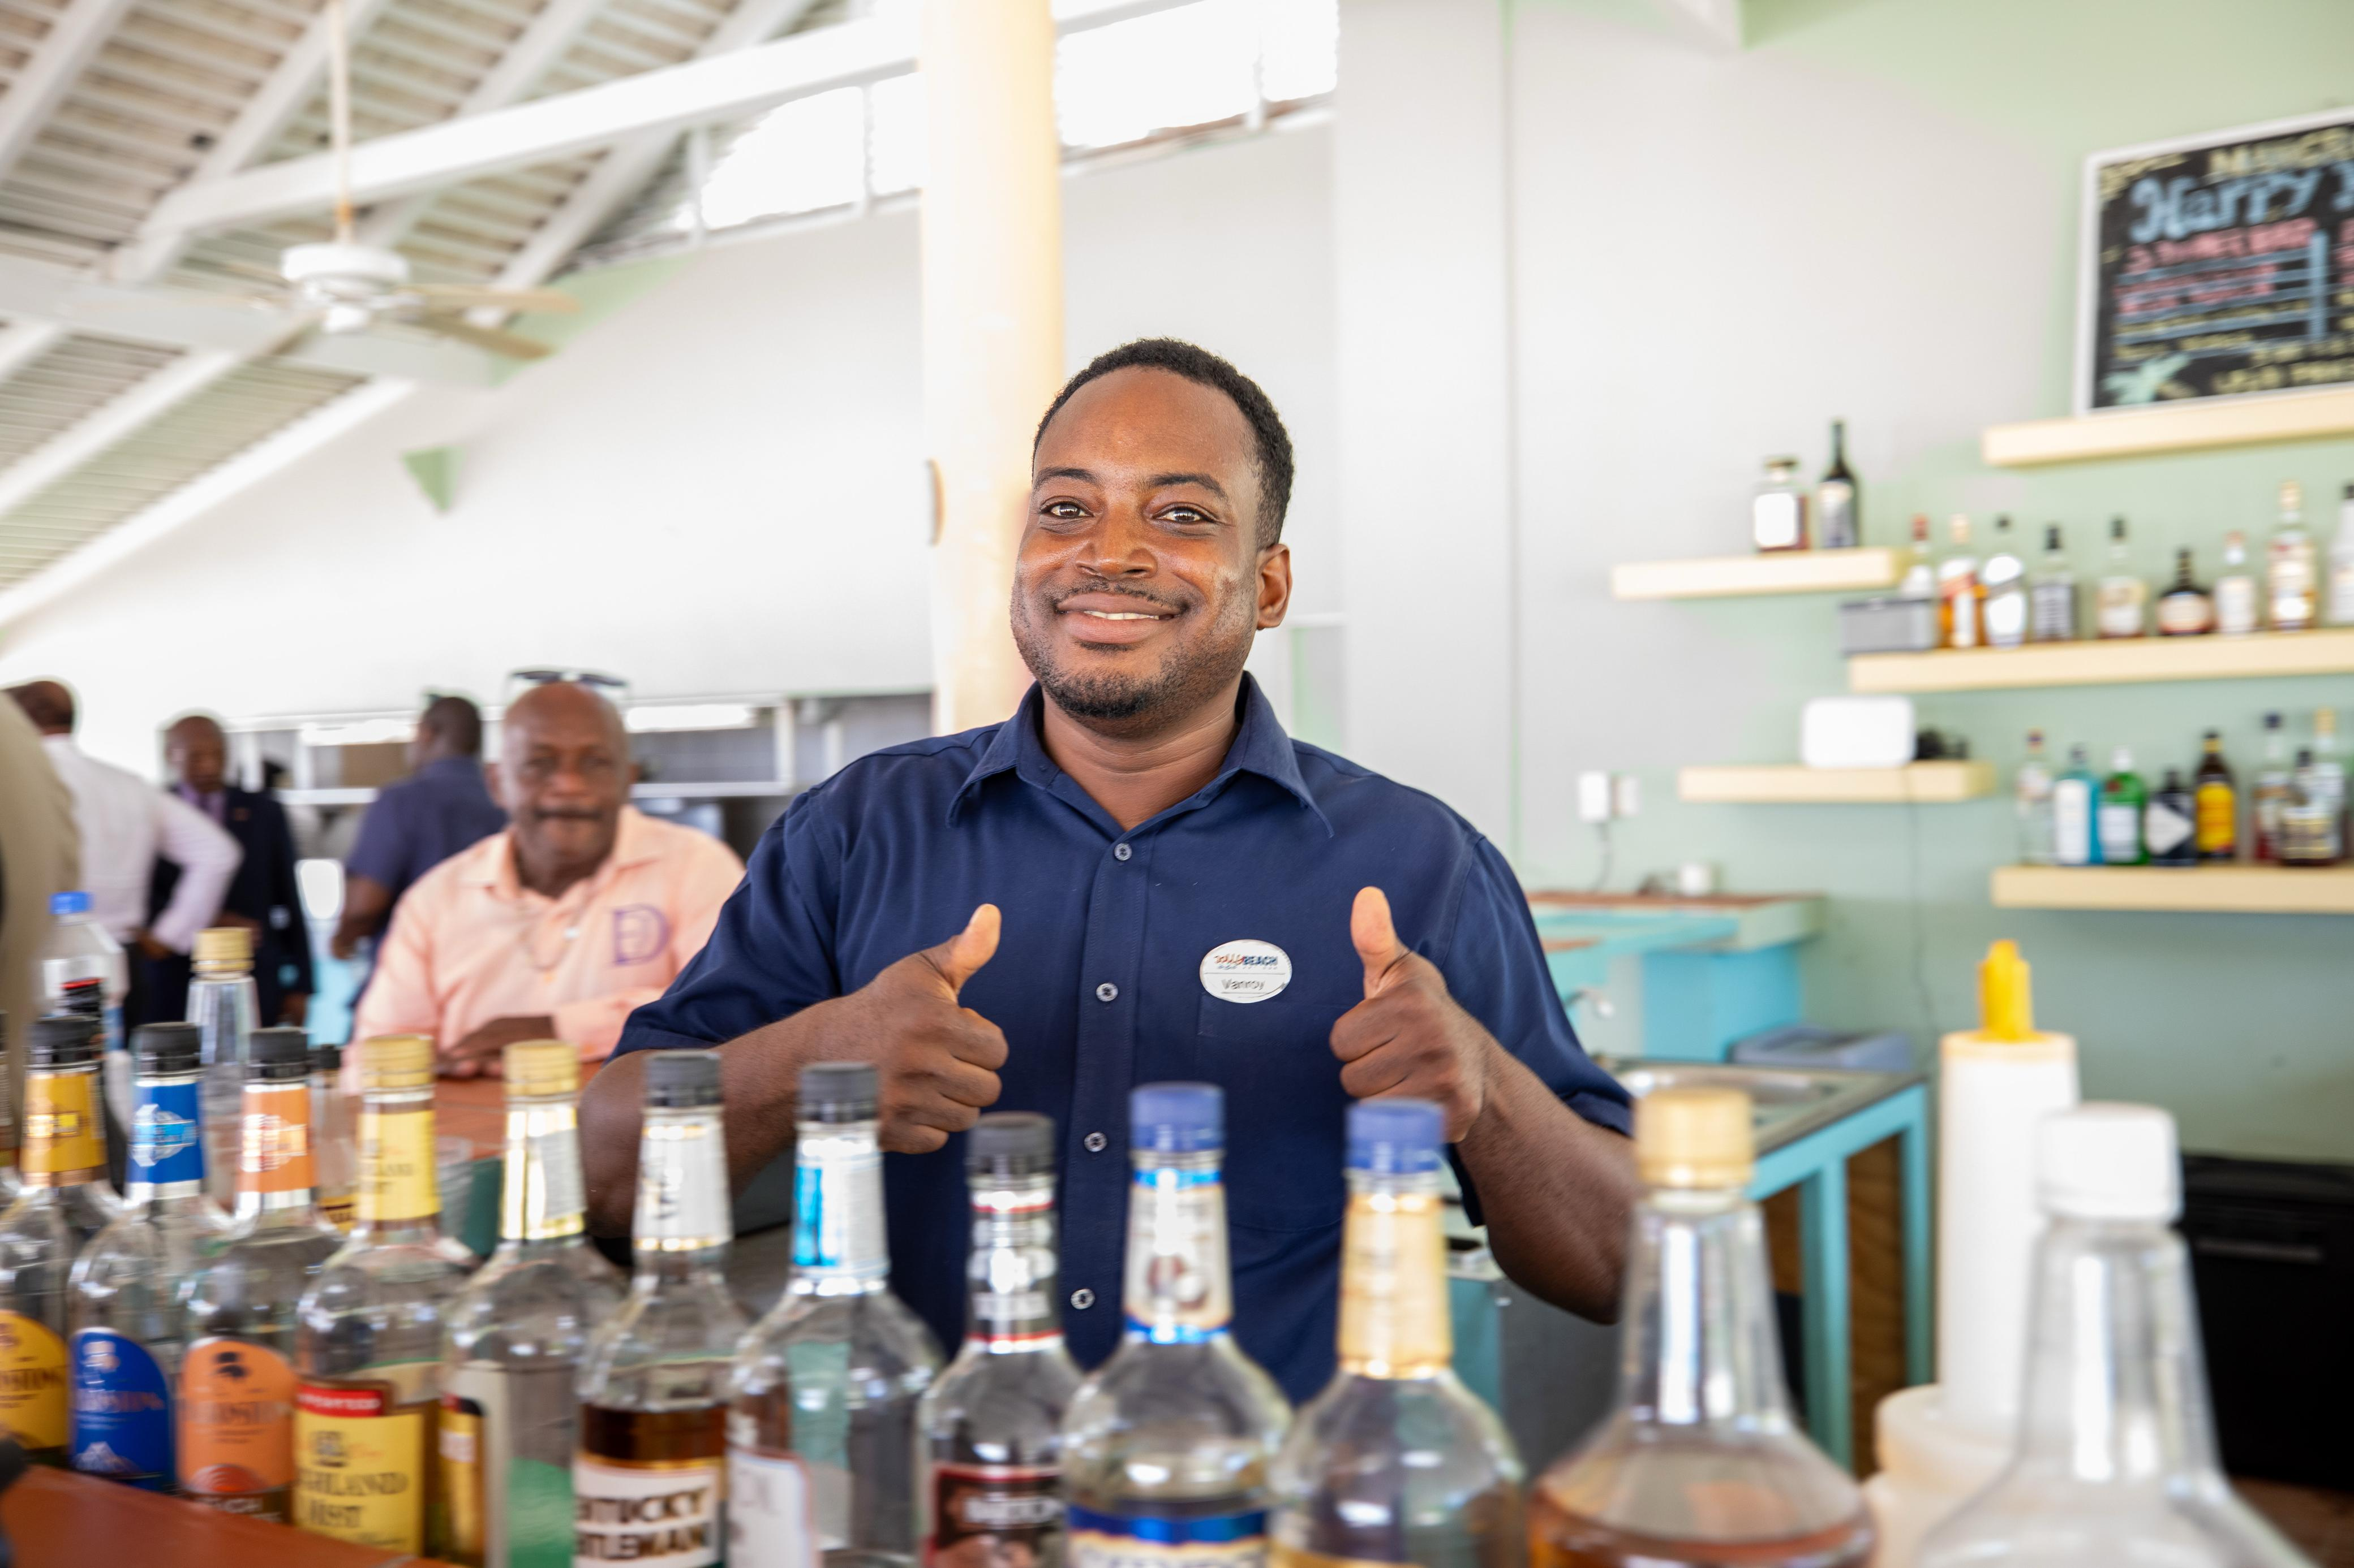

Supporting Information
Exchange-rate note: All US$ equivalents shown in brackets use EC$2.70 = US$1.00.

Appendix A: CIP Programme Performance (2019–2024)
Year | Total Applications | Real-Estate Share (%) | Revenue (US$ m) | Notes
2019 | 512 | 12% | 45.2 | Pre-pandemic baseline
2020 | 238 | 15% | 24.7 | COVID downturn
2021 | 482 | 14% | 52.3 | Strong rebound
2022 | 755 | 16% | 72.1 | Record year
2023 | 801 | 15% | 68.4 | Continued robust demand
2024† | 739 (H1 only) | 15% | 63.0 (H1) | On track to match 2023

Appendix B: Tourism Sector Key Indicators
Metric | 2022 | 2023 | 2024 (est.) / Source
Total Visitor Arrivals | 390,000 | 420,000 | 440,000 / National Statistics Office
Tourism’s Share of GDP | 58% | 60% | 61 % / WTTC
Average Occupancy Rate (Comparable Resorts) | 63% | 67% | 68 % / Hospitality Benchmarking Group
Average RevPAR Growth | 5% | 8% | +6 % / Regional Hotel Association
Cruise Calls | 1,104 | 1,234 | 1,275 / Port Authority

Appendix C: Bond Instrument Details
Issue Date: June 15, 2010
Original Principal: EC$330 million
Coupon Rate (if serviced): 6 %
Outstanding Principal (2025): EC$330 million
Accrued Interest Unpaid: ~EC$120 million
Current Market Value: ~EC$0 (in default)

Appendix D: Governance & Milestones Timeline
Milestone | Target Date
CIP Regulatory Approval Secured | Q4 2025
Launch Sale of Existing Units | Q1 2026
Ground-breaking for Expansion | Q2 2026
Completion of 200-Room Expansion | Q4 2027
Complete Operational Handover of Jolly Beach | Q2 2028

Appendix E: Comparable Pension-Fund Case Studies
Fund | Real-Estate Allocation | IRR (5 yr) | Notes
Ireland’s National Treasury | 15% | 12% | Diversified global portfolio
Ontario Teachers’ Pension (OTPP) | 18% | 10% | Significant hospitality holdings
New Zealand Superannuation Fund (NZSF) | 12% | 11% | Inflation-linked assets

Appendix F: Jolly Beach Hotel — Renovation & Expansion Analysis
- Rooms currently in use: 318.
- Additional rooms to be returned to service: 32.
- Total available rooms (post-reconciliation): 350.
All 350 rooms will be offered under the CIP Programme. Owners may occupy their units for approximately two weeks per year; otherwise, the rooms will remain in the managed rental pool perpetually.
CIP pricing & projected proceeds (summary):

CIP Pricing & Projected Net Proceeds for Jolly Beach Hotel
Item | Gross (EC$) (US$) | Net proceeds (EC$) (US$)
Existing units — 350 @ EC$900,000 | EC$315,000,000  (US$116,666,667) | EC$222,352,941  (US$82,352,941)
Expansion units — 200 @ EC$1,300,000 | EC$260,000,000  (US$96,296,296) | EC$200,000,000  (US$74,074,074)
Total (both phases) — gross / net | EC$575,000,000  (US$212,962,963) | EC$422,352,941  (US$156,427,015)
Average annual net yield (10-year average) | - | EC$42,235,294 / year  (US$15,642,702 / year)

Renovation & Expansion Capex (planning)
Item | EC$ | (US$)
Room upgrades (350 rooms) | EC$5,197,500 | (US$1,925,000)
A/C upgrade | EC$1,147,500 | (US$425,000)
Kitchen upgrade | EC$472,500 | (US$175,000)
Electrical upgrade | EC$4,320,000 | (US$1,600,000)
Sewage plant (100,000 gpd) | EC$2,403,000 | (US$890,000)
Conference facility (7,500 sq ft) | EC$4,860,000 | (US$1,800,000)
Roof refurbishment | EC$877,500 | (US$325,000)
New spa (4 rooms) | EC$1,012,500 | (US$375,000)
Cistern (100,000 gal) | EC$594,000 | (US$220,000)
Laundry equipment | EC$405,000 | (US$150,000)
Rescue boat / watersports / golf carts | EC$405,000 | (US$150,000)
Reception / restaurants / common areas | EC$2,295,000 | (US$850,000)
General maintenance (3-yr phased) | EC$1,215,000 | (US$450,000)
Subtotal (planning capex) | EC$25,204,500 | (US$9,335,000)
Recommended contingency (10%) | EC$2,520,450 | (US$933,500)
Planning capex (with contingency) | EC$27,724,950 | (US$10,268,500)

Room-Revenue Models — Baseline and Target (annual)
Exchange-rate note: EC$2.70 = US$1.00. EC$ values shown first; US$ equivalents in brackets.

A. Conservative short-term model — 318 operational rooms
Assumption / Metric | Value
Operational rooms | 318
Current occupancy | 62%
ADR (current) | US$229 (≈ EC$618.30)
Annual room revenue — baseline | US$16,479,618.60 (≈ EC$44,495,969)
Target occupancy/ADR after upgrades | 75% / US$249
Annual room revenue — target | US$21,676,072.50 (≈ EC$58,545,397)
Annual uplift (target − baseline) | US$5,196,453.90 (≈ EC$14,049,428)
If ADR uplift = US$30 — annual revenue | US$22,546,597.50 (≈ EC$60,865,813)
If ADR uplift = US$30 — uplift vs baseline | US$6,066,978.90 (≈ EC$16,369,844)

B. Medium / steady-state model — 350 CIP units (owners use 14 nights/year)
Assumption / Metric | Value
Total CIP units | 350
Owner private use | 14 nights/year (≈ 2 weeks)
Rental-pool available room-nights (annual) | 122,850 (≈ 336.58 rooms nightly)
Occupancy (baseline) | 62%
ADR (baseline) | US$229
Annual room revenue — baseline | US$17,442,243.00 (≈ EC$47,094,056)
Target occupancy/ADR after upgrades | 75% / US$249
Annual room revenue — target | US$22,942,237.50 (≈ EC$61,943,039)
Annual uplift (target − baseline) | US$5,499,994.50 (≈ EC$14,848,983)
If ADR uplift = US$30 — uplift | US$6,421,004.50 (≈ EC$17,337,812)

Key totals & takeaways
Item | EC$ | (US$)
Total projected net CIP proceeds (both phases) | EC$422,352,941 | (US$156,427,015)
Planning capex (with 10% contingency) | EC$27,724,950 | (US$10,268,500)
Conservative short-term annual uplift (318 rooms) | EC$14,049,428 | (US$5,196,454)
Steady-state annual uplift (350 units) | EC$14,848,983 | (US$5,499,995)
Average annual net CIP proceeds (10-yr average) | EC$42,235,294 / year | (US$15,642,702 / year)
Appendix G - Jolly Beach Hotel: Management Accounts to 31 Dec 2024 (P&L), One-page Annotated Summary
Annotated Summary:
Management accounts are provided by hotel management; an independent review/audit is in progress. All figures in US$; EC$ equivalents shown at EC$2.70 = US$1.00
Headline performance (YTD to 31 Dec 2024)
- Total revenue (YTD): US$8.09M (EC$21.84M)
- Rooms revenue (YTD): US$6.83M (EC$18.44M)
- Gross operating profit (GOP): US$4.56M (EC$12.31M)
- Net profit (after management fees, interest & tax): US$1.11M (EC$2.99M)
Key operating indicators (derived from the P&L)
The hotel is operating profitably on a recurring basis (positive GOP and positive net profit), demonstrating its viability as a going concern.
- Room business is the dominant revenue line (84% of total revenue). F&B, ancillary, and activity income contribute the remainder.
- The cost structure shows scope for performance improvement via capex (energy, A/C, and electrical efficiencies) and management optimization.
Reconciliation guidance (how this P&L ties to the paper’s headline numbers)
The P&L demonstrates positive recurring operating earnings, which validate the paper's assertion that operational uplift (better management + capex) can raise net profitability materially.
Appendix G 1
Jolly Beach – Government of Antigua
SUMMARY STATEMENT OF PROFIT & LOSS (USD)
As of December 31, 2024 — First Page Summary

Line Item | Current Month |  |  |  | Year to Date
 | Act | Bud | Var | LY | Act | Bud | Var | LY
REVENUE
Rooms | 828,982 | 1,201,746 | (372,764) | 727,196 | 6,827,397 | 10,094,084 | (3,266,687) | 5,213,924
Food & Beverage | 102,097 | 47,261 | 54,837 | 35,872 | 448,202 | 408,824 | 39,378 | 210,504
Tour Desk | 4,936 | 5,227 | (291) | 0 | 45,843 | 51,405 | (5,562) | 0
Spa | 2,838 | 5,855 | (3,017) | 3,628 | 22,172 | 57,578 | (35,406) | 31,424
Gift Shop | 5,203 | 6,534 | (1,331) | 6,229 | 45,374 | 64,256 | (18,882) | 38,160
Other Income | 220,999 | 67,052 | 153,948 | 44,119 | 699,755 | 661,047 | 38,708 | 355,217
TOTAL REVENUE | 1,165,055 | 1,333,674 | (168,619) | 817,044 | 8,088,743 | 11,337,195 | (3,248,451) | 5,849,228
COST OF SALES
Food | 174,667 | 171,075 | (3,592) | 114,641 | 1,190,998 | 1,635,066 | 444,068 | 910,201
Beverage | 52,387 | 72,829 | 20,443 | 27,374 | 359,917 | 693,169 | 333,251 | 322,401
Gift Shop | 1,561 | 1,960 | 399 | 5,207 | 14,331 | 19,277 | 4,946 | 17,761
COS Discounts F&B | (10,602) | 10,602 | (21,204) | (38,080) | (82,489) | 0 | 82,489 | (38,080)
TOTAL COST OF SALES | 218,013 | 245,864 | 27,851 | 147,222 | 1,482,758 | 2,347,512 | 864,753 | 1,212,282
PAYROLL
Rooms | 54,972 | 46,786 | (8,186) | 50,473 | 479,841 | 449,334 | (30,507) | 418,724
Food & Beverage | 116,524 | 143,027 | 26,503 | 132,752 | 1,049,208 | 1,330,764 | 281,556 | 907,031
Activities | 2,131 | 3,962 | 1,830 | 2,034 | 20,807 | 40,728 | 19,921 | 20,634
Tours | 3,186 | 1,886 | (1,300) | 0 | 22,926 | 20,257 | (2,669) | 0
Spa | 1,082 | 1,875 | 793 | 1,502 | 13,853 | 19,531 | 5,678 | 15,602
Gift Shop | 2,204 | 3,195 | 991 | 2,980 | 27,446 | 34,970 | 7,523 | 21,953
TOTAL PAYROLL | 180,098 | 200,730 | 20,632 | 189,740 | 1,614,081 | 1,895,584 | 281,503 | 1,383,944
OTHER EXPENSES
Rooms | 20,754 | 20,585 | (169) | 12,494 | 163,911 | 211,425 | 47,514 | 191,720
Food & Beverage | 62,136 | 22,266 | (39,869) | 19,561 | 171,946 | 204,917 | 32,971 | 170,306
Activities | 24,662 | 12,536 | (12,125) | 25,574 | 92,368 | 122,320 | 29,952 | 72,936
Tours | 69 | 218 | 149 | (831) | 1,114 | 2,094 | 980 | 0
Spa | 0 | 199 | 199 | 0 | 417 | 2,042 | 1,625 | 676
Gift Shop | 330 | 246 | (83) | 593 | 574 | 2,425 | 1,851 | 2,159
TOTAL OTHER EXPENSES | 107,950 | 56,051 | (51,899) | 57,391 | 430,329 | 545,222 | 114,892 | 437,798
GROSS OPERATING PROFIT | 658,994 | 831,028 | (172,034) | 422,690 | 4,561,575 | 6,548,877 | (1,987,302) | 2,815,204
OVERHEAD EXPENSES
Administration | 121,384 | 55,931 | (65,453) | 109,042 | 611,890 | 551,696 | (60,194) | 488,453
Security | 27,480 | 19,958 | (7,522) | 20,758 | 225,878 | 226,031 | 153 | 206,723
Repairs & Maintenance | 70,499 | 80,370 | 9,871 | 83,811 | 809,086 | 905,943 | 96,858 | 625,864
Utilities | 110,548 | 130,675 | 20,127 | 159,183 | 1,303,052 | 1,275,584 | (27,468) | 1,390,048
TOTAL OVERHEAD EXPENSES | 329,911 | 286,934 | (42,977) | 372,793 | 2,949,906 | 2,959,254 | 9,348 | 2,711,088
NET OPERATING PROFIT (LOSS) | 329,083 | 544,095 | (215,012) | 49,897 | 1,611,669 | 3,589,623 | (1,977,954) | 104,116
OTHER (Below the Line)
SJC Management Fee | 72,071 | 80,112 | 8,041 | 48,314 | 485,333 | 680,273 | 194,940 | 349,552
Insurance | 1,303 | 1,004 | (299) | 915 | 14,474 | 12,053 | (2,421) | 11,982
NET PROFIT (LOSS) | 255,709 | 462,978 | (207,269) | 668 | 1,111,862 | 2,897,297 | (1,785,435) | (257,419)
Payroll Cost | 269,369 | 288,916 | 19,548 | 262,581 | 2,411,061 | 2,853,557 | 442,497 | 2,015,046
% on Revenue (Payroll as % of Revenue) | 23% | 23% |  |  | 30% | 30%
